About Dr. Neil Warshawsky DDS, MS, PC
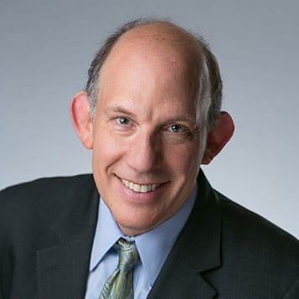
Dr. Neil Warshawsky attained all his college training from the University of Illinois where her earned a total of five college degrees, culminating in his Orthodontic Certificate. Today he divides his time among the three pillars that support his practice.
Dr. Neil leads a world-class staff at Get It Straight Orthodontics. With four locations spread across the city of Chicago and suburbs, they are a very high energy, dynamic practice that concentrates on delivering customized orthodontic solutions in comfortable, inviting atmospheres. High-end cosmetic efficiency is the focus of this patient-driven practice. From a paperless approach, to the online portal, to the mobile website, the practice is completely designed to utilize today’s most advanced technologies to make sure every patient’s objectives are met and every question answered.

When he is not in his private practice, Dr. Warshawsky is an Associate Professor of Orthodontics at the Craniofacial Center at the University of Illinois Health Center. With more than 18 years of cleft palate team experience and a vast knowledge of 3D imaging, he manages a large majority of the craniofacial cleft palate orthodontic cases. Dr. Warshawsky feels very fortunate to have the opportunity to practice orthodontics, and enjoys the ability to give back routinely at the University in a place that “Makes a Difference where it matters most.”
Lastly, to stay current, Dr. Warshawsky may be found on the road some 40+ times per year lecturing to audiences literally around the world on a number of subjects including building clear aligners, lingual orthodontics, and the use of fixed skeletal anchorage for more efficient mechanics.
With more than 18 articles published, and several active clinical trials current at any given moment, Dr. Neil stays busy. Outside of work, he is an Assistant Scoutmaster for Boy Scouts Troop 156 in Glenview, Illinois. When he is not working he may be found at home with his high school sweetheart or one of their three kids, or fishing at their family cabin in the Northern woods of Wisconsin.
Title: Evaluating 9-12 Hour Wear NiTime Aligners
Can Treatment Efficiency Improve while Reducing Wear Time?
Dr. Warshawsky presents a variety of cases treated with a new hyper-elastic material. Stay on track the first time and be more efficient with your treatment time. More efficiency in your treatment yields higher ROI on your cases. Don’t work harder, work smarter.
Topics that will be covered include
The first FDA cleared aligner system for night only wear.
- Recognize that refinement is an outdated process
- Define a new concept in CAT—transformative hyper-elastic material
- List the reasons why 20+ hours per day wear in CAT is not a requirement in all clear aligner systems
- Hyper-elasticity is a transformative new property for clear aligners that improves treatment efficiency and opens the door for reduced wear time.
- Case Review on several finished cases treated with NiTime aligners.

